**Loving Learning Theory Carnival**

Monday, July 22

7:15-9:15 pm

**PROTOCOL**

**BOOTH Two**

**Constructivism**

|  |  |
| --- | --- |
| **Learning GOAL:**  **Participants access their prior knowledge to make sense of a group of related artifacts and collaboratively construct an understanding of the significance of those artifacts.** | |
| **Directions**   1. **Observe the poster of constructivism.** 2. **Directions:**     1. **Divide into groups of three or four.**    2. **Observe each individual artifact**       1. **What questions do you have about each artifact?**       2. **What personal connections might you have to the artifacts?**       3. **What is the purpose or use of each artifact?**       4. **How are the artifacts related?**    3. **As a group, create a profile of the artifacts** 3. **To debrief, return to the constructivist image and discuss how this lesson incorporated both social and cognitive constructivism.** 4. **STAMP/GIVE STICKER (?) the CARNIVAL BOOKLET** | |
| **Activities**   1. **The group observes the poster of constructivism. Ask: What do you observe about social and cognitive constructivism?** 2. **Each group gets an artifact bag to observe and discuss** 3. **Groups discuss artifacts and prepare summaries.** 4. **Group discusses how this represents constructivism and why we need this theory in our understanding of learning. What kind of learning does constructivism represent and why is it important for our students** | **Materials**   * **Poster of Constructivism** * **Bag of artifacts** |

[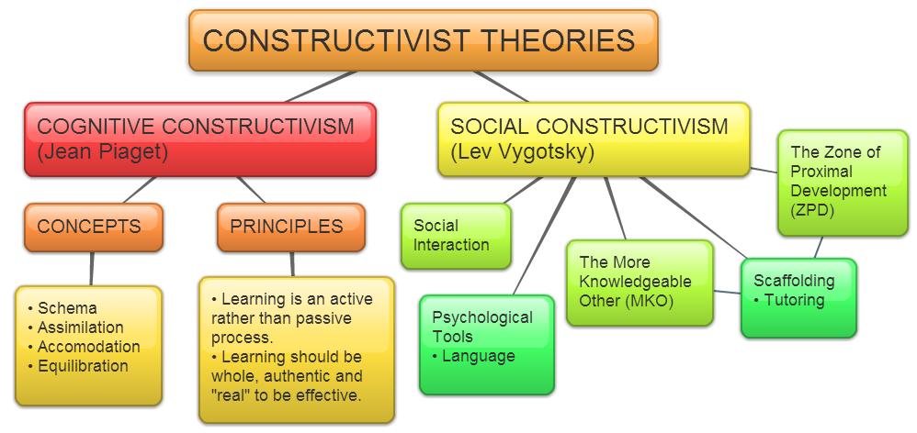](https://owelpapel.wordpress.com/tag/notes-and-resources/)